Lot 61 Reduced Levels and Sections at Side Boundaries

Using the information given, do the following:

- Book staff reading (rise & fall method) onto the rise & fall template
(Do the arithmetical check to confirm the correct booking in rise & fall column)
- 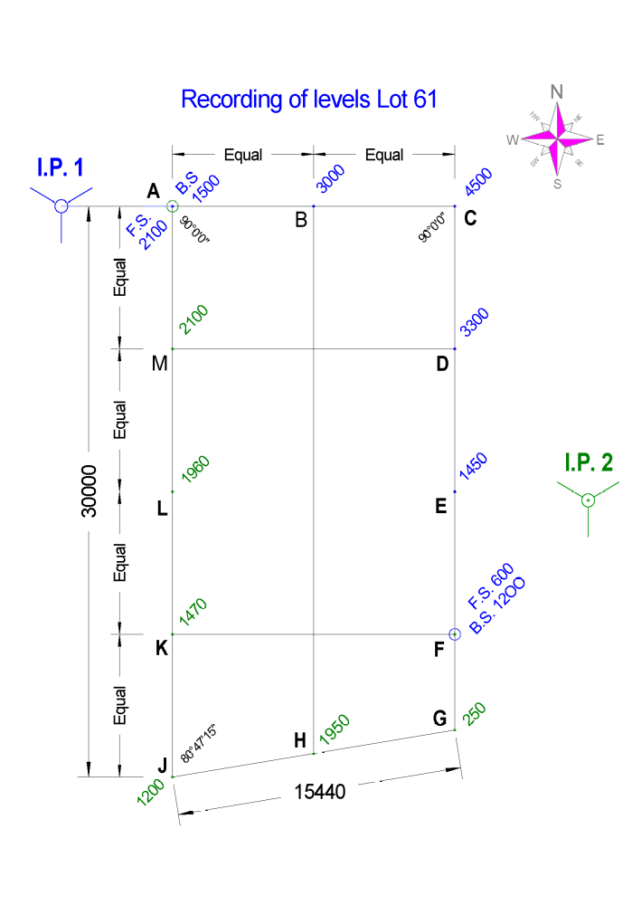Use the assumed reduced level (RL = 10.00 m) at Station ‘A’ to calculate reduced level for each station in alphabetical order.
- Draw section views (ground profile) of the site boundaries using a horizontal scale of 1:200 and a vertical scale of 1:50 or as indicated on sections. Select a baseline for the vertical section of RL 6 m)

Rise & Fall Template

Station | Back- | Inter- | Fore- | Rise | Fall | Reduced | Distance | Remarks
Station | sight | mediate | sight | Rise | Fall | level | Distance | Remarks
A

Section views must show Station & distances on baseline and all RL’s on graph

BOUNDARY A - C

BOUNDARY C - G

Section views must show Station & distances on baseline and all RL’s on graph

BOUNDARY G - J

BOUNDARY J - A

